STQA MINI PROJECT
Title: Software Testing and Quality Assurance of a Student Result Management System (SRMS)
Objectives: 1) To develop an application for entering student details and subject marks.
2) To validate student information and marks.
3) To calculate total marks, percentage, and grade.
4) To perform black-box, white-box, unit, and integration testing.
5) To prepare test cases, bug reports, and a final testing report.

Problem Statement: Create a small application by selecting relevant system environment platform and programming languages. Narrate concise Test Plan consisting features to be tested and bug taxonomy. Prepare Test Cases inclusive of Test Procedures for identified Test Scenarios. Perform selective Black-box and White-box testing covering Unit and Integration test by using suitable Testing tools. Prepare Test Reports based on Test Pass/Fail Criteria and judge the acceptance of application developed.

Outcomes: 1) Verified input validation and result calculation using black-box testing.
2) Performed white-box testing and unit testing of the grade calculation function.
3) Conducted integration testing to verify interaction between application modules.
4) Prepared test cases, bug reports, and a final testing report.
5) All 20 recorded test executions passed, with no defects observed in the tested scenarios.

Hardware and Software Requirements:
Hardware:- intel i3+ processor, RAM 4GB+, 64GB storage
Software:- Operating system, Python and required libraries, streamlit, IDE, web browser

Theory: Software Testing and Quality Assurance (STQA) is the process of verifying and validating software to ensure that it meets specified requirements and works correctly.
The Student Result Management System is developed using Python and Streamlit. It accepts student details and subject marks, validates the inputs, calculates total marks and percentage, assigns grades, and displays student results.
Different software testing techniques are used to check the correctness and reliability of the application:
1. Black-Box Testing: Tests application functionality by providing inputs and checking expected outputs without examining internal code.
2. White-Box Testing: Examines the internal program logic, conditions, and execution paths.
3. Unit Testing: Tests individual functions independently. In this project, the grade calculation function is tested using Python's unittest framework.
4. Integration Testing: Verifies that different modules, such as input validation, result calculation, grade assignment, and result display, work correctly together.
5. Defect Reporting: Records software defects identified during testing, including their description, severity, and status.
The application is tested using valid and invalid inputs, including empty fields, marks outside the permitted range, duplicate roll numbers, and zero marks. Expected outputs are compared with actual outputs to evaluate correctness.
Thus, software testing helps verify the functionality and reliability of the Student Result Management System and improves confidence in its operation.

Algorithm:
- Start the application.
- Initialize the Streamlit interface and result storage.
- Accept the student's name, roll number, and subject marks.
- Validate required fields and check that marks are between 0 and 100.
- Check for duplicate roll numbers and invalid marks.
- If the input is invalid, display an error message; otherwise, calculate total marks and percentage.
- Assign a grade based on the percentage.
- Save and display the student's result.
- Perform black-box, white-box, unit, and integration testing.
- Compare actual results with expected results and record defects, if any.
- Stop.

Step 1: Create Website
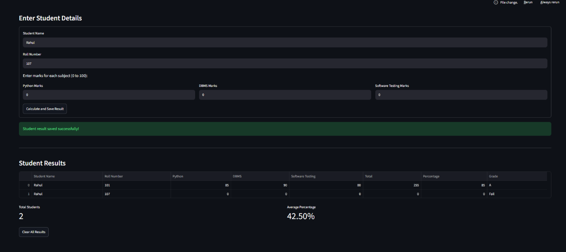

Step 2: Software Test Plan
1. Objective
The objective of testing is to verify that the Student Result Management System accepts valid student information, validates incorrect inputs, calculates results accurately, and displays student records correctly.
2. Scope of Testing
The following features will be tested:
- Student name and roll number validation.
- Subject marks validation.
- Total marks and percentage calculation.
- Grade calculation.
- Duplicate roll number detection.
- Displaying and clearing student results.
3. Testing Approach
The application will be tested using:
- Black-box testing: Testing the application using inputs and expected outputs without examining the internal code.
- White-box testing: Checking the program's internal logic, conditions, and execution paths.
- Unit testing: Testing individual functions, such as grade calculation.
- Integration testing: Checking whether validation, calculation, and result display work together correctly.
- Manual testing: Entering different inputs and checking the actual output.
4. Test Environment
- Operating System: Windows
- Programming Language: Python
- Framework: Streamlit
- Editor: Visual Studio Code
- Browser: Google Chrome
- Libraries: Pandas and Streamlit
5. Entry Criteria
- The application code is available.
- Python and required libraries are installed.
- The application starts successfully.
6. Exit Criteria
- All planned test cases have been executed.
- Actual results have been compared with expected results.
- Any defects found have been documented.
- Critical calculation and validation errors have been resolved.
7. Limitations
The current version stores student records in session memory. Records are not permanently stored in a database and may be lost when the session resets.

Step 3: Black-box testing — test case documentation
Test ID | Test scenario | Expected result | Observed result | Status
TC01 | Enter valid student details | Result calculated and saved | Student result saved successfully with correct total, percentage, and grade. | Pass
TC02 | Leave student name empty | Required-field error | Error message displayed: “Student name and roll number are required.” | Pass
TC03 | Leave marks empty | Marks-required error | Error message displayed: “Please enter marks for all three subjects.” | Pass
TC04 | Enter marks above 100 | Range validation error | Error message displayed: “Marks must be between 0 and 100.” | Pass
TC05 | Enter text instead of marks | Numeric validation error | Error message displayed: “Marks must contain valid numbers only.” | Pass
TC06 | Enter a duplicate roll number | Duplicate error | Error message displayed: “This roll number already exists.” | Pass
TC07 | Enter zero marks for all subjects | Result saved with grade Fail | Student result saved with total 0, percentage 0.00%, and grade Fail. | Pass

Observation: Black-box testing was performed on the Student Result Management System using valid and invalid inputs. The test cases covered required fields, marks validation, duplicate roll numbers, result calculation, and grade assignment. The actual outputs were compared with the expected outputs, and any mismatches were to be recorded as defects.

Step 4: White Box Testing
White-box testing examines the internal code, conditions, and decision paths to verify that the program logic works correctly.
Test ID | Input (%) | Code condition tested | Expected grade | Status
WB01 | 95 | percentage >= 90 | A+ | Pass
WB02 | 85 | percentage >= 80 | A | Pass
WB03 | 75 | percentage >= 70 | B | Pass
WB04 | 65 | percentage >= 60 | C | Pass
WB05 | 45 | percentage >= 40 | D | Pass
WB06 | 0 | All conditions false; else executes | Fail | Pass
WB07 | 90 | Boundary of A+ grade | A+ | Pass
WB08 | 40 | Boundary of D grade | D | Pass

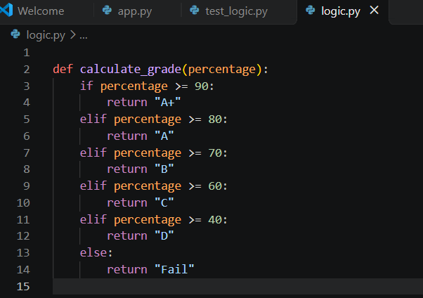
White-box testing was performed by examining the internal logic of the grade calculation function. Eight test cases were used to verify the conditional statements, grade outcomes, and boundary values. All eight tests passed, and every grade outcome was exercised by the test cases.

Step 5: Unit testing
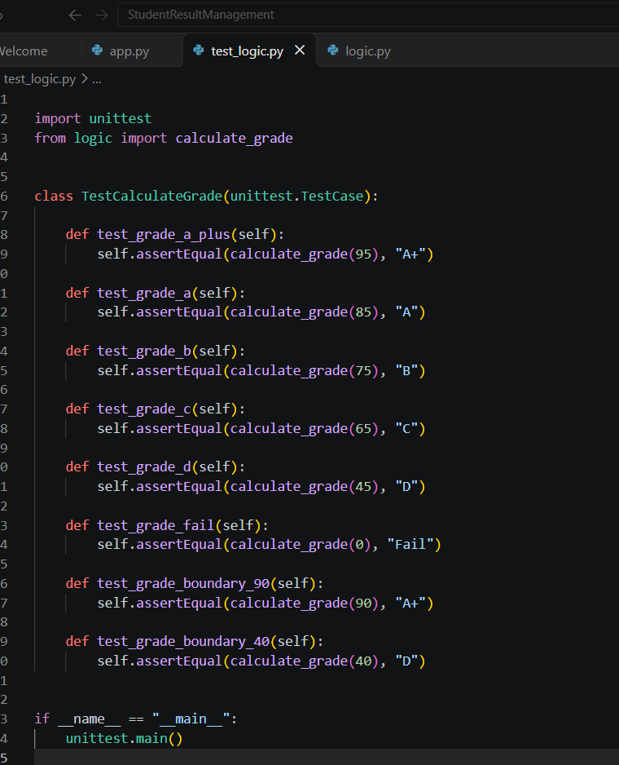
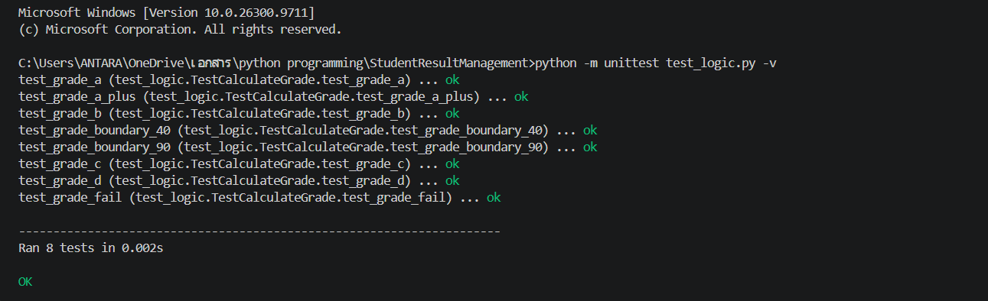

Step 6: Integration Testing
Integration testing checks whether different parts of an application work correctly together.
Test ID | Test scenario | Expected result | Observed result | Status
IT01 | Enter Rahul, roll no. 201, marks 85, 90, 80 | Total 255, percentage 85%, grade A | Total 255, percentage 85.00%, grade A displayed successfully. | Pass
IT02 | Enter a new student with marks 0, 0, 0 | Total 0, percentage 0%, grade Fail | Total 0, percentage 0.00%, grade Fail displayed successfully. | Pass
IT03 | Enter a new student with marks 95, 95, 95 | Total 285, percentage 95%, grade A+ | Total 285, percentage 95.00%, grade A+ displayed successfully. | Pass
IT04 | Enter marks above 100 | Error displayed; invalid record not saved | Validation error displayed, and the invalid record was not saved. | Pass
IT05 | Enter a duplicate roll number | Error displayed; duplicate record not saved | Duplicate roll number error displayed, and the duplicate record was not saved. | Pass

Integration Testing Report
Objective: To verify the interaction between input validation, result calculation, grade calculation, and result display modules.
Procedure: Student details and marks were entered through the Streamlit interface. The system's validation messages, calculated totals, percentages, grades, and saved records were checked against expected results.
Expected outcome: Valid records should be saved with correct calculations, while invalid inputs and duplicate roll numbers should be rejected.
Conclusion: Integration testing is performed to verify that the individual modules work correctly together. Final pass/fail status should be recorded after executing all planned integration test cases.
Step 7: Bug report and defect classification
Bug Report
Project: Student Result Management System
Testing Type: Manual, Black-box, Unit, and Integration Testing
Field | Details
Bug ID | BR-001
Bug Title | No defects observed during executed tests
Module | Student Result Management System
Severity | Not applicable
Priority | Not applicable
Status | No defect reported
Description | The executed test cases produced the expected results during testing.
Expected Result | The system should validate inputs, calculate results, assign grades, and display student records correctly.
Actual Result | The observed outputs matched the expected outputs in the tests performed.

Conclusion: No defects were reported in the executed test cases. This does not guarantee that the application is completely bug-free.
Step 8: Final testing Report
Final Software Testing Report
Project Title: Student Result Management System (SRMS)
1. Objective
To test the functionality, input validation, result calculation, grade assignment, and result display of the Student Result Management System.
2. Testing Performed
The following testing techniques were performed:
- Manual Testing: Tested valid and invalid student inputs.
- Black-Box Testing: Verified application outputs for different test inputs.
- White-Box Testing: Examined grade calculation logic and decision branches.
- Unit Testing: Tested the calculate_grade() function using Python's unittest framework.
- Integration Testing: Verified the interaction between validation, calculation, grade assignment, and result display.
3. Test Execution Summary
Testing Activity | Test Cases | Result
Manual / Black-Box Testing | 7 | All passed
Unit Testing | 8 | All passed
Integration Testing | 5 | All passed
Total | 20 | All passed
4. Defect Summary
No defects were observed in the executed test cases. All tested functionalities produced the expected results.
5. Limitations
- Student records are stored temporarily in session memory.
- Permanent database storage is not implemented.
- Testing was limited to the selected test cases and environment.
6. Conclusion
The Student Result Management System was tested using manual, black-box, white-box, unit, and integration testing techniques. All 20 recorded test executions passed, and no defects were observed in the tested scenarios. The application performed as expected for the inputs tested.

